
New World Industries Inc.

LT-9 Wireless Transmitter
The LT-9 wireless Transmitter is 3.5” x 5.5” in size. This industrial unit can be mated with NWI’s current line of wireless receivers. All LT-9 transmitters come from the factory with a pre-install address (1 in16 million). An optional rubber boot that encloses the transmitter is also available from NWI. The LT-9 will transmit up to 8 individual signals to the wireless receiver using buttons 1 thru 8. Button 9 will turn the transmitter on or off.
Setting up the LT-9 to transmit to an existing receiver:
- Depending on the receiver type the LT-9 is being mated to will dictate how this first step is completed. If you are mating to a 3” x 3” open top enclosure the black programming button will be exposed. When mating to a covered enclosure the receiver cover must be removed exposing the black programming button. Once the programming button is accessed complete the following step.
- Power up the receiver (green LED will light-up)
- Depress the black programming button and the red LED will begin to flash.
- Firmly depress button 1 on the LT-9 transmitter with-in 15 seconds.
- Wait until the red LED stops flashing (approx. 15 seconds).
- As a test, now depress buttons 1 thru 8 and the red LED on the receiver should light when a button is depressed. Once tested, replace cover if necessary. The LT-9 is now ready for use.
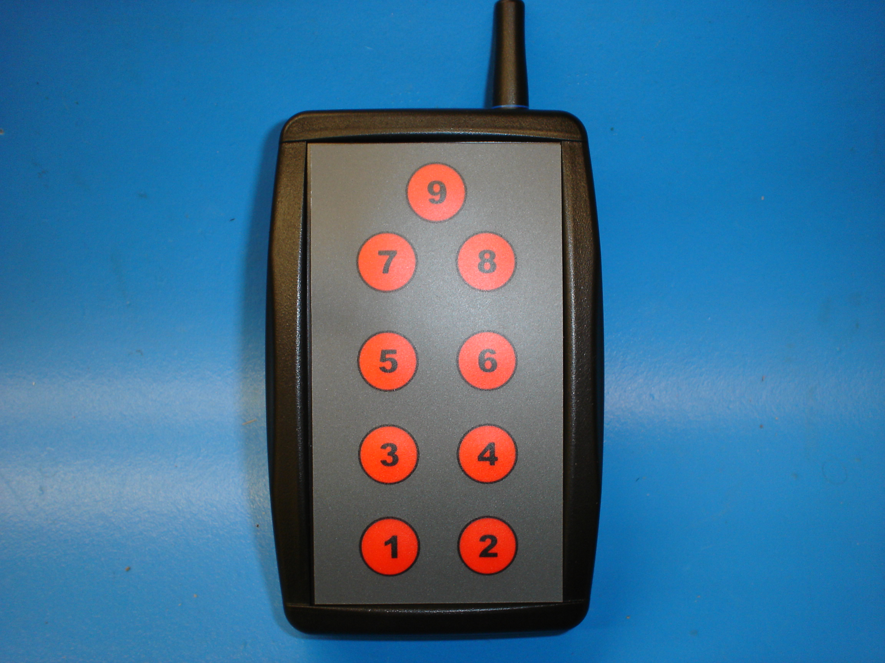

How to change the transmitter address:
- Remove cover screws from backside of transmitter enclosure
- Separate enclosure to expose circuit board as shown in picture bellow
- Depress programming button and red LED will begin to flash
- Depress buttons 1 thru 8 on transmitter keypad
- LED will stop flashing within 15 seconds
- Carefully assemble enclosure replacing screws
- The LT-9 now has a new, 1 in 16 million address and is ready to use.
Programming LED
Programming Button

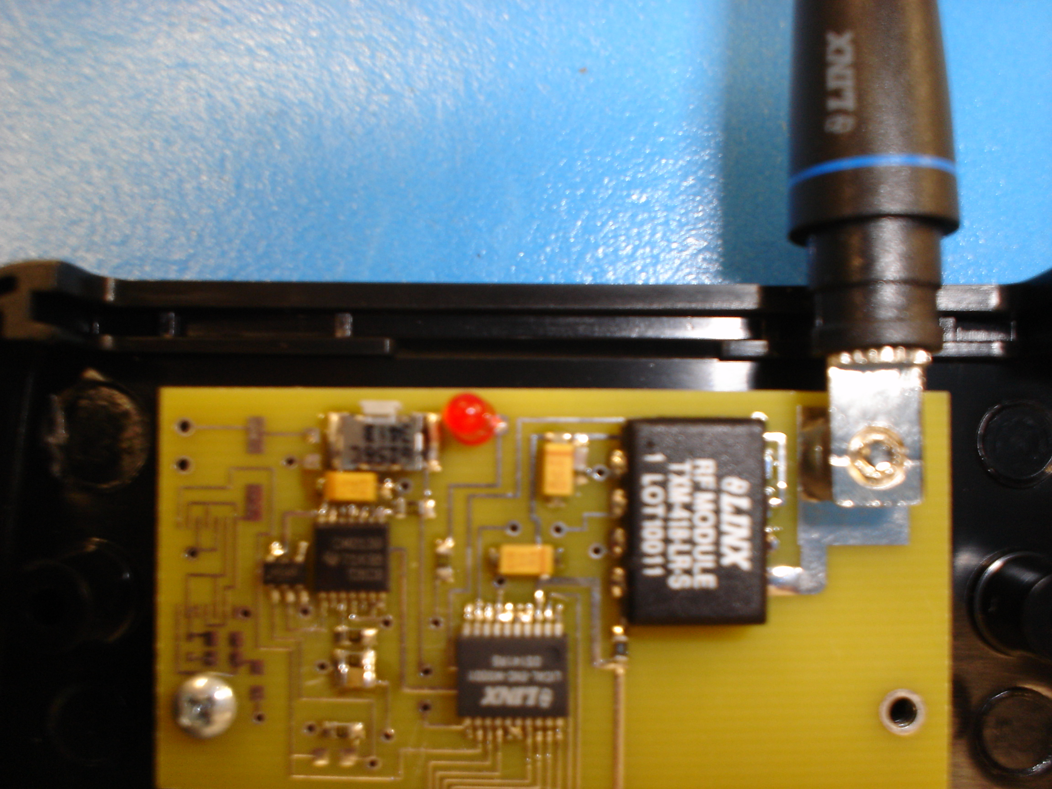

Battery Replacement
The transmitter uses a standard CR2032 lithium button cell battery. In normal use it will provide 1 to 2 years of operation. To replace the battery, remove the 4 small screws and gently pry apart the 2 halves. Remove the battery by sliding it out from underneath the retainer. Observe the battery polarity when replacing.

